Name -Supriya Kumari
Class -3AB
Submission of Intro to Web Development
1. Difference between frontend, backend, full-stack
Frontend builds the user interface using HTML, CSS, and JavaScript. Backend handles server logic, authentication, and databases using technologies like Node.js, Python, or Java. Full-stack developers work on both frontend and backend.
Example: In Amazon, the product page is frontend, order processing is backend, and a full-stack developer can build both.
- Client-server model
Client (Browser) -> HTTP Request -> Web Server -> Database (if needed) -> Web Server -> HTTP Response -> Browser displays webpage.
3. Browser requests
User enters URL, browser sends HTTP request, server processes it, returns HTML/CSS/JS, browser renders the page.
4. Tools
VS Code: code editor
Google Chrome: testing
Git: version control
Node.js: JavaScript runtime
Live Server: local development
GitHub: code hosting.
5. Web server
A web server stores and delivers web pages. Examples: Apache, Nginx, Microsoft IIS, Node.js (Express).
6. Roles
Frontend Developer: Responsible for constructing user-facing interfaces using code. Translates UI/UX designs into responsive web pages and ensures seamless client interactions.
Backend Developer: Builds and maintains server-side logic, application programming interfaces (APIs), authentication workflows, and system architecture.
Database Administrator (DBA): Manages, secures, optimizes, and maintains database systems. Ensures data integrity, creates backups, optimizes query performance, and manages access permissions.
7. VS Code
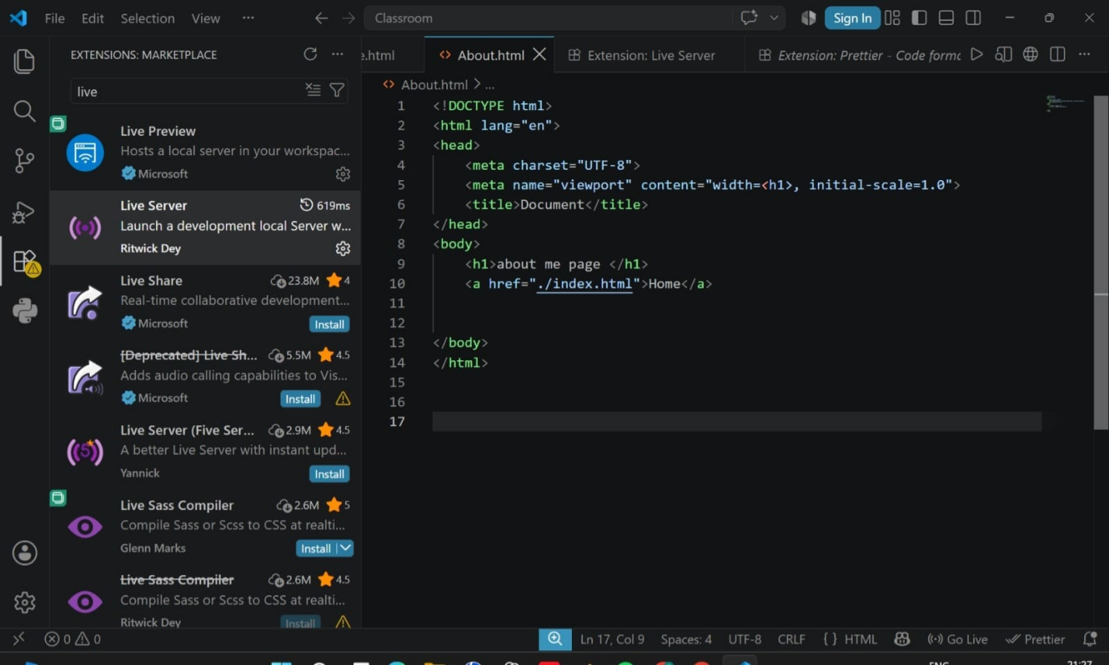

8. Static vs Dynamic
Static websites show fixed content (portfolio). Dynamic websites generate content based on users/data (Facebook, Amazon).
9. Browsers
- Google Chrome: Uses the Blink engine.
- Mozilla Firefox: Uses the Gecko engine.
- Apple Safari: Uses the WebKit engine.
- Microsoft Edge: Uses the Blink engine (Chromium-based).
- Brave: Uses the Blink engine.
How Rendering Engines Differ
- Parsing & Standards Support: Engines parse CSS and HTML with slight variations in web standards compliance, which can lead to minor layout inconsistencies across platforms.
- Execution Performance: Different engines optimize JavaScript execution through different JS engines (e.g., Chrome's V8 vs. Firefox's SpiderMonkey vs. Safari's JavaScriptCore).
- Speed & Memory Footprint: Engines like WebKit prioritize low power usage on mobile devices, while Blink is tuned for high performance desktop rendering.
10. Labeled Web Architecture Flow
CLIENT
User Browser / Mobile App
1. HTTP/HTTPS Request
4. HTTP/HTTPS Response
APIs / SERVER
Web Server / API Gateway
(Processes Logic, Authentication, Routing)
2. Database Queries
3. Processed data
DATABASE
Relational / NoSQL Database
(MySQL, PostgreSQL, MongoDB, etc.)
Client (Frontend):
- User interface (e.g., Google Chrome, Mobile Application) where the user interacts with the app.
- Sends HTTP requests to the server and displays the returned response (HTML/CSS/JS/JSON).
APIs / Web Server (Backend):
- Acts as an intermediate bridge between client and database.
- Receives incoming HTTP requests, checks user authentication, processes business logic via REST APIs and communicates with the database.
Database:
- Stores dynamic application data persistently (e.g., User profiles, passwords, product items).
- Executes database queries (SQL/NoSQL) sent by the backend server and returns the requested data.
Data Flow Order:
- Step 1: Client sends an HTTP Request to the API/Server.
- Step 2: Web Server queries the Database for required data.
- Step 3: Database responds with data back to the Server.
- Step 4: Web Server sends the final HTTP Response back to the Client.

